Lecture 1

SQL Is structured query lang

Used to create, delete, update, read STRUCTURED DATA

Structured data is tabular, containing cols and rows

The software used to perform this operations using SQL lang is called DBMS

Microsoft SQL is such DBMS

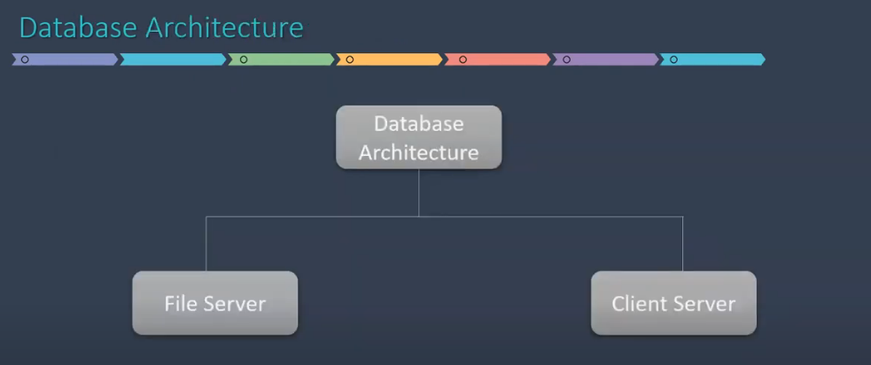

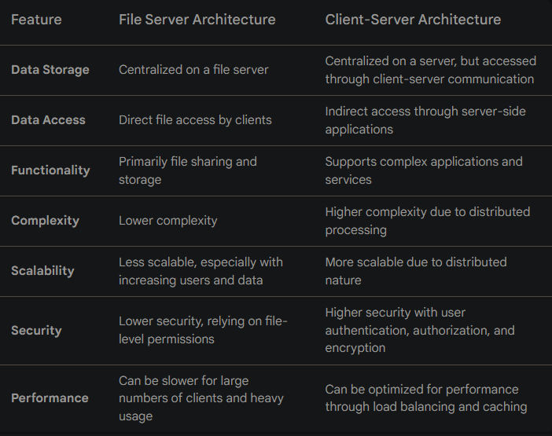

Types of commands

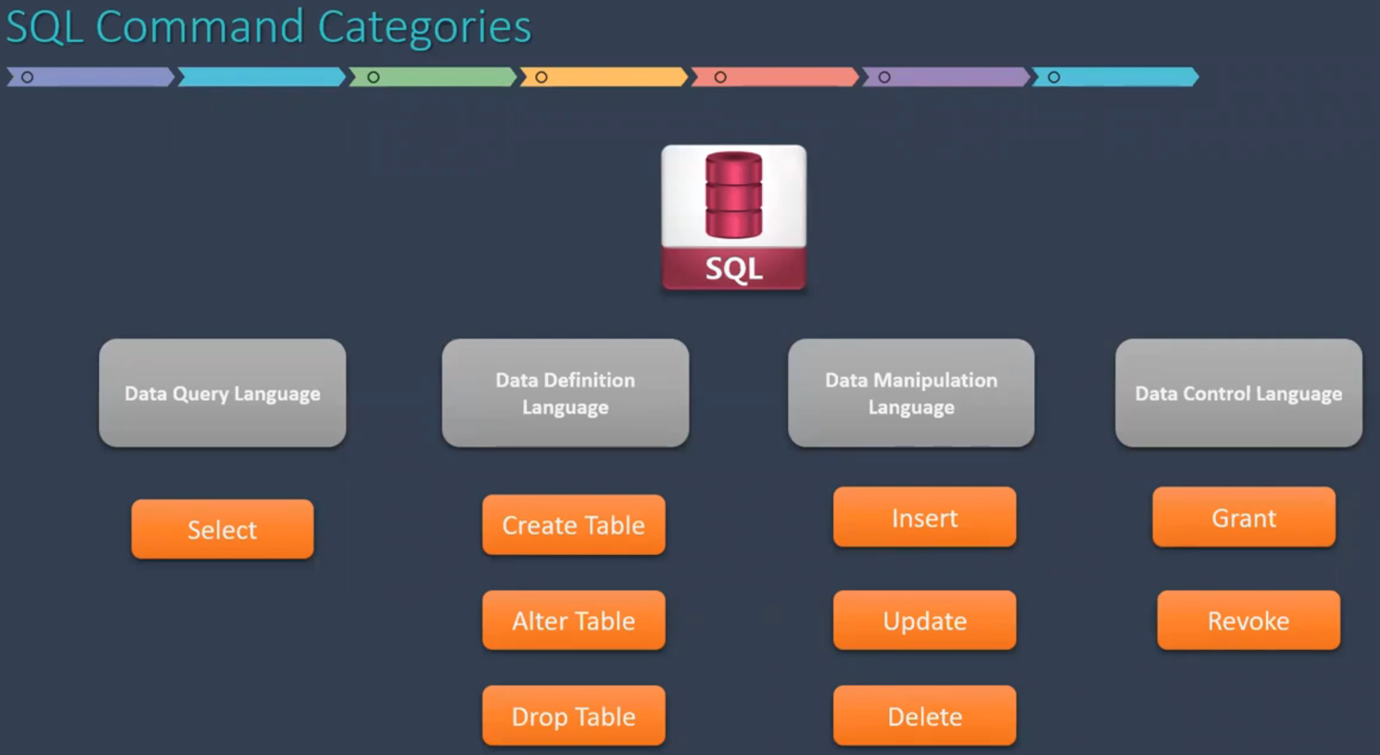

Data types

Numeric

Character

Date time

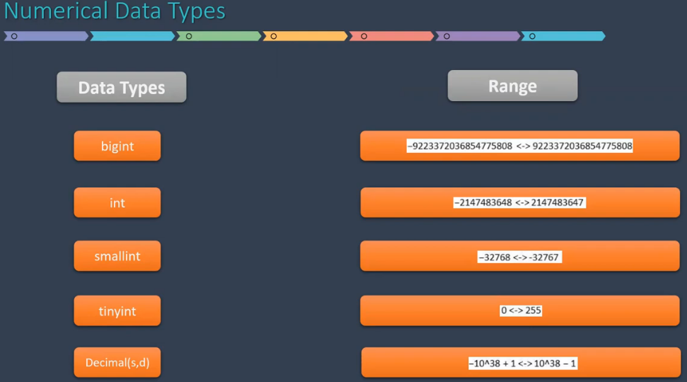

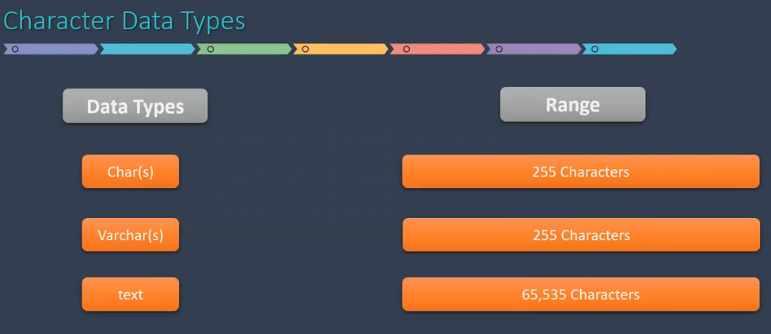

Char vs Varchar

Char(30) will allocate 30 memory blocks even if less space is actually occupied, static memory allocation.

Varchar(30) will not alloactate all 30 blocks together, allocation depends on actual value size, it means max allocation having dtype as Varchar(30) can be 30. Dynamic memory allocation.

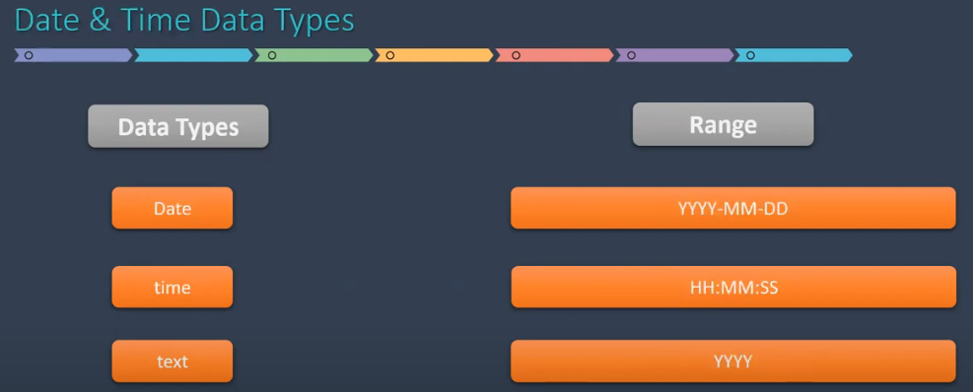

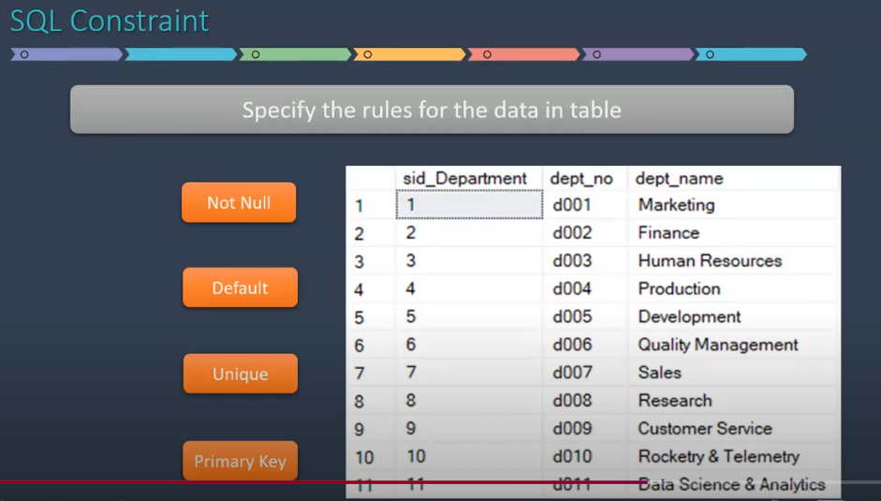

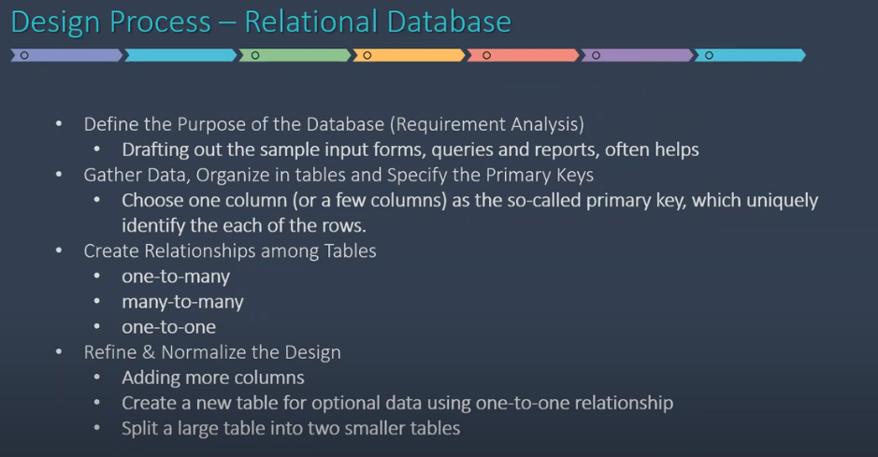

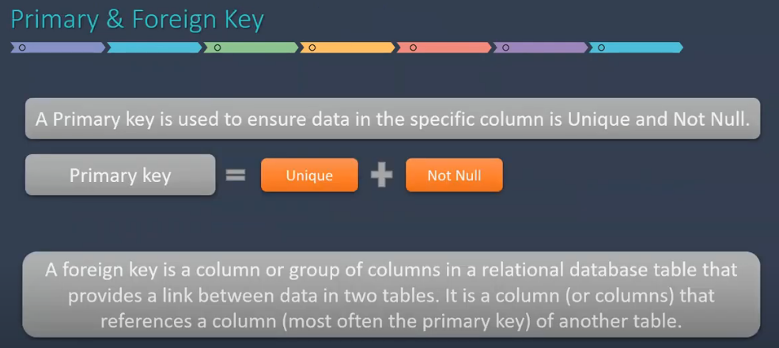

We cannot drop a database in use. To drop DB in use use different DB and the fire drop command.

In SQL, a view is a virtual table that presents a specific set of data from one or more tables. It's essentially a saved SQL query that can be treated like a real table.

The CREATE VIEW statement is used to create a view. Here's the basic syntax:

SQL

CREATE VIEW view_name AS

SELECT column1, column2, ...

FROM table_name(s)

WHERE condition(s);

**Key Points to Remember:**

* Views don't store data directly. They simply provide a different way to access existing data.
* Changes made to the underlying tables are reflected in the view.
* Views can be updated and deleted, but the underlying data remains unchanged.
* Views can be used to create more complex views, allowing for a hierarchical structure.